ABSTRACT
The rapid advancement of Artificial Intelligence and Deep Learning has enabled the development of intelligent systems capable of solving real-world problems. One such application is in the domain of health and fitness, particularly in yoga practice.
This project presents a Yoga Pose Detection System that utilizes deep learning techniques to classify yoga poses from images and videos. The system is designed to assist users in identifying correct yoga postures without the need for a physical trainer. It provides an efficient and user-friendly platform where users can upload images or videos and receive predictions regarding the performed yoga pose.
The system is implemented using a Flask-based web application integrated with a pre-trained deep learning model. The model is capable of extracting features and classifying poses with good accuracy. This project demonstrates the practical application of Convolutional Neural Networks (CNNs) in image classification tasks.

INTRODUCTION
Yoga is an ancient practice that promotes physical health, mental stability, and overall well-being. However, performing yoga poses correctly is crucial to avoid injuries and gain maximum benefits. Beginners often struggle with maintaining correct posture due to the lack of proper guidance.
With the advancement of Artificial Intelligence, it is now possible to develop systems that can automatically analyze and interpret visual data. This project leverages deep learning techniques to build a system that can detect and classify yoga poses from images and videos.
The system aims to bridge the gap between traditional yoga learning and modern technology by providing an automated, accessible, and intelligent solution.

PROBLEM STATEMENT
Many individuals practicing yoga at home lack proper guidance, which leads to incorrect posture and reduced effectiveness. Hiring a personal trainer is not always feasible due to cost and availability constraints.
Therefore, there is a need for a system that:
- Automatically detects yoga poses
- Provides instant feedback
- Works with both images and videos
- Is accessible through a simple interface

OBJECTIVES
The primary objectives of this project are:
- To develop a deep learning-based system for yoga pose classification
- To support both image and video input
- To design a user-friendly web interface
- To achieve reliable prediction accuracy
- To demonstrate the use of AI in fitness applications

LITERATURE REVIEW
Recent studies in computer vision have shown that Convolutional Neural Networks (CNNs) are highly effective in image classification tasks. Architectures such as VGG, ResNet, and Xception have been widely used for feature extraction.
The Xception model, in particular, improves performance by using depthwise separable convolutions, making it efficient and accurate for image-based tasks. This project builds upon such advancements to implement yoga pose classification.

METHODOLOGY
The system follows a structured pipeline:

Step 1: Data Collection
- A dataset of yoga pose images is collected
- Each image is labeled according to its pose

Step 2: Data Preprocessing
- Images are resized to a fixed dimension
- Normalization is applied
- Data is prepared for model input

Step 3: Model Training
- A deep learning model (Xception-based) is used
- The model learns features from images
- Training is performed using labeled data

Step 4: Model Integration
- The trained model is saved in .h5 format
- Integrated into the Flask backend

Step 5: Web Application Development
- Frontend developed using HTML, CSS, JavaScript
- Backend handles file upload and prediction

Step 6: Prediction
- User uploads image/video
- Model processes input
- Output (predicted pose) is displayed

SYSTEM ARCHITECTURE
The system consists of three main components:

1. Frontend Layer
- Provides user interface
- Handles input (image/video upload)

2. Backend Layer
- Built using Flask
- Processes requests and communicates with model

3. Model Layer
- Deep learning model performs classification
- Returns predicted label

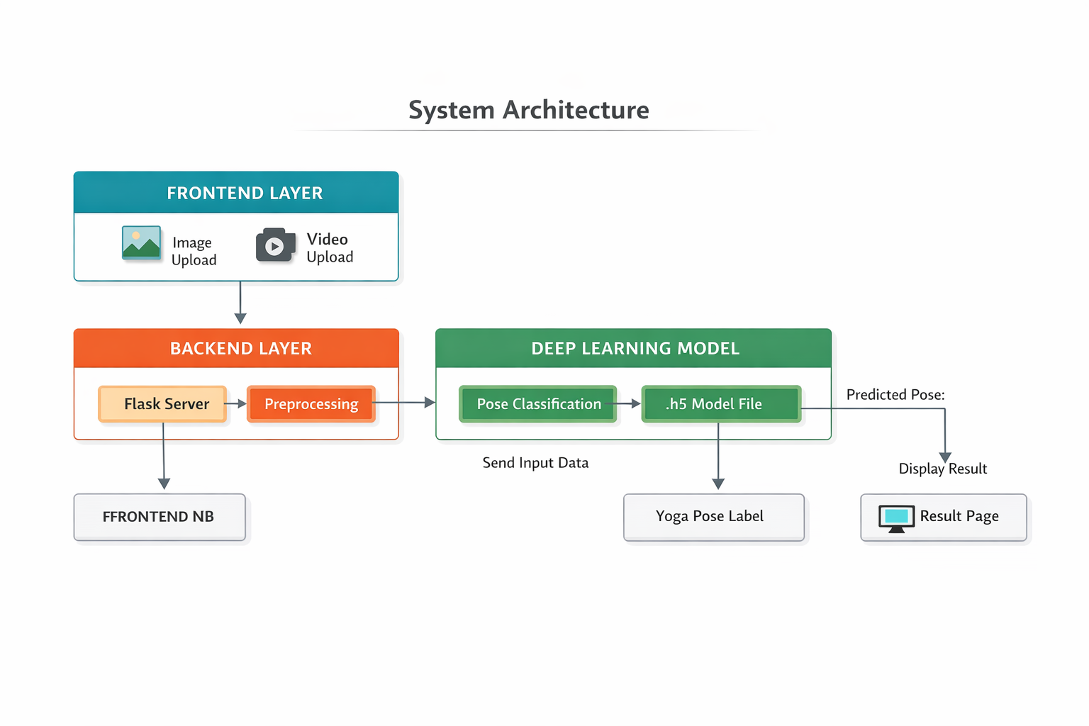

TECHNOLOGY STACK

Frontend
- HTML5
- CSS3 (Responsive design implementation)
- JavaScript

Backend
- Python
- Flask Framework

Machine Learning
- TensorFlow / Keras
- Pre-trained Xception Model

IMPLEMENTATION DETAILS

User Interface
- Clean and responsive design
- Navigation bar for easy access
- Separate pages for image and video input

File Handling
- Supports image and video upload
- Displays preview before prediction

Prediction Module
- Input is preprocessed
- Model generates prediction
- Output is displayed dynamically

FEATURES
- Image-based yoga pose detection
- Video-based pose detection
- User-friendly interface
- Fast processing and prediction
- Modular design

RESULTS
The system successfully classifies yoga poses based on the input provided by the user. The predictions are generated quickly and displayed through the web interface.

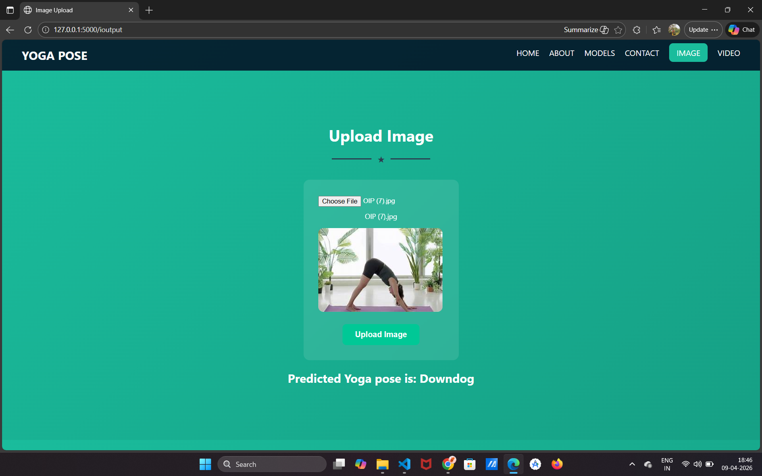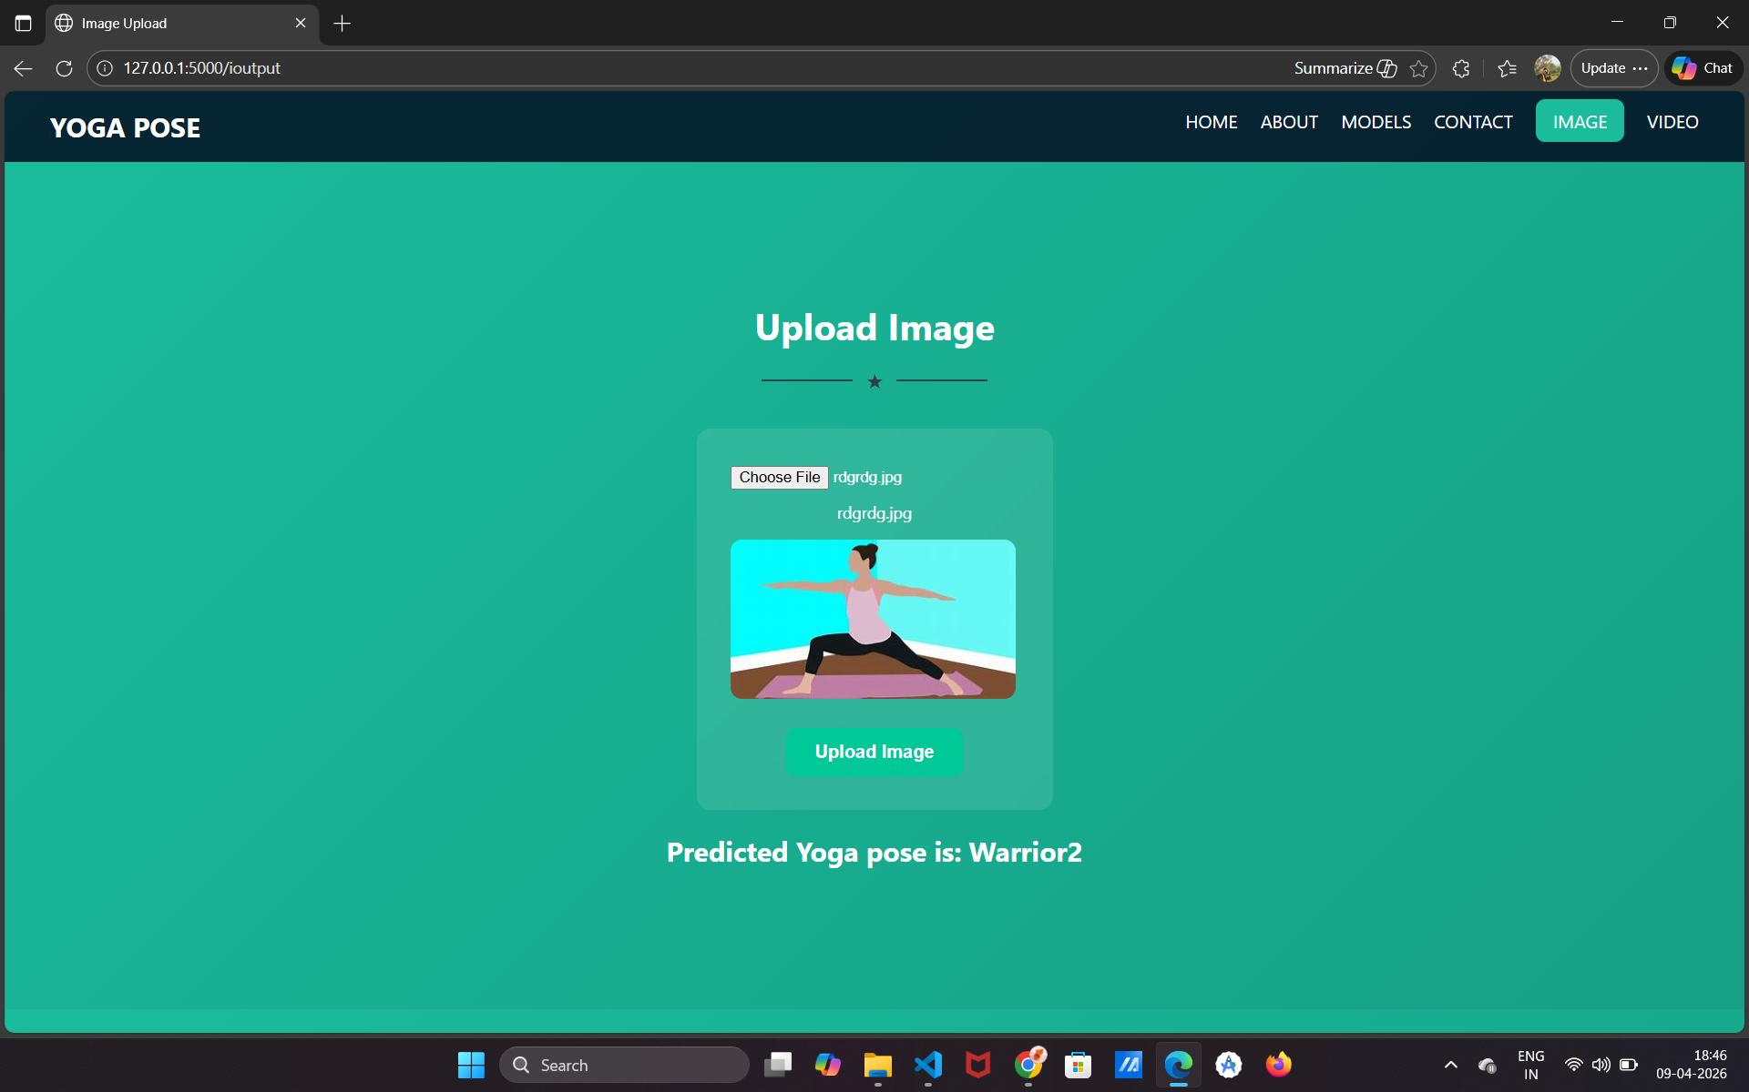

ADVANTAGES
- Reduces dependency on trainers
- Enables self-learning
- Cost-effective solution
- Easy to use and accessible
- Demonstrates real-world AI application

LIMITATIONS
- Accuracy depends on dataset quality
- Sensitive to lighting and background conditions
- Limited number of yoga poses supported
- Real-time detection not fully implemented

FUTURE SCOPE
- Real-time pose detection using webcam
- Mobile application development
- Integration with wearable devices
- AI-based posture correction suggestions
- Expansion of dataset for higher accuracy

CONCLUSION
The Yoga Pose Detection System demonstrates how deep learning can be effectively applied in the domain of health and fitness. The system provides an intelligent and user-friendly platform for identifying yoga poses.
This project highlights the potential of AI in transforming traditional practices into modern, technology-driven solutions. With further improvements, the system can be extended into a fully functional real-time fitness assistant.

REFERENCES
- TensorFlow Documentation
- Keras API Guide
- Research papers on CNN and Image Classification
- Online resources on Xception Architecture

